3G611R (3G611R+)-How to limit the computers in the LAN to access the Internet by client Filter function?
Product line: 3G Question category: Function configurations

Q：Why we should configure Client Filter function?
A：To benefit your further management to the computers in the LAN, you can control some PCs with certain IP address to access to Internet by setting Client filter to achieve it.

The topology is as below
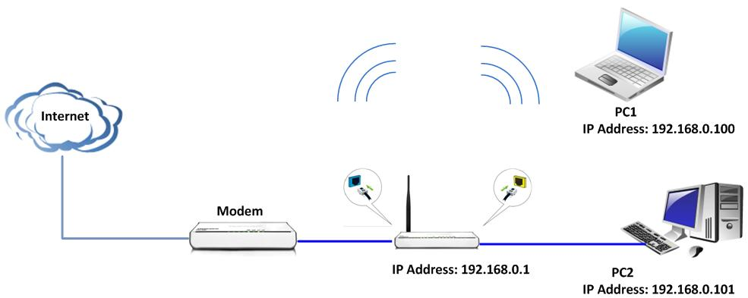
The steps are as followings:
- Login to the management page of the router.
- Click Security Settings→Client Filter in the gray menu on the left.
On the right size of the page, please tick Client Filtering Settings.
For example, we want to limit the computer with IP address during 192.168.0.100~192.168.0.150 to access the internet from 8:00am to 18:00pm from Monday to Friday. And the computer with other IP Address can access internet. You can set the router following the picture as below.

